Title (Arial Nova, 18 pt, bold, centered)
N. Surname^{1,*}, N. Surname², N. Surname³
¹ Affiliation; ² Affiliation (Arial Nova, 10 pt, Italics)
*Email address

The abstract must be written in English and submitted in MS Word format. The main title must be centred with respect to the page and written in bold style. Only the name of the presenting author should be underlined. The author names should appear below the main title, separated by commas with font Arial Nova 11. Affiliation and email address font is Arial Nova 10.
The text abstract must be separated from the heading by one line.
The abstract must not exceed one page (A4 size). The text font is Arial Nova (size 12 pt for the main text) with 1 pt as line spacing.

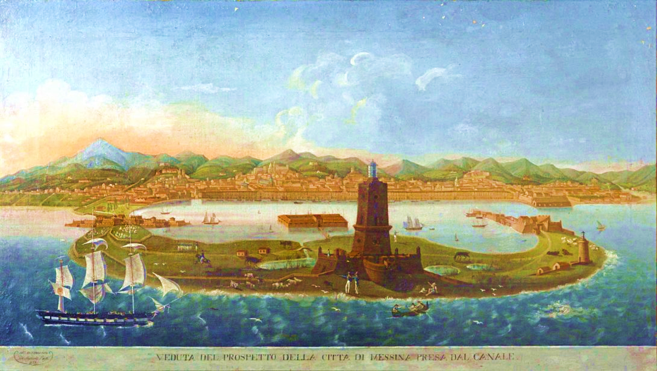
Figure 1: caption.

References should appear as superscript numbers (without brackets)¹ both in the main text and in the list. For references list, the font script is Arial Nova10.

References

¹ N. Surname, N. Surname Journal, Year, Volume, initial page – last page.
² N. Surname, N. Surname Journal, Year, Volume, initial page – last page.

